**Maryport Church of England Primary School**

**Computing Policy**

1. **Vision and Aims:**

**Purpose of study**

A high-quality computing education develops pupils' computational thinking and creativity, helping them understand and influence the world. It connects closely with maths, science, and design technology. At its core is computer science, teaching how digital systems work and how to apply this through programming. Pupils also learn to use information technology to create content and become digitally literate, preparing them for the future workplace and life in a digital world.

**Aims**

The national curriculum for computing aims to ensure that all pupils:

* Can understand and apply the fundamental principles and concepts of computer science, including abstraction, logic, algorithms and data representation.
* Can analyse problems in computational terms, and have repeated practical experience of writing computer programs in order to solve such problems.
* Can evaluate and apply information technology, including new or unfamiliar technologies, analytically to solve problems.
* Are responsible, competent, confident and creative users of information and communication technology.

**Source: *Computing programme of Study: key stages 1 and 2, DfE, 2014***

**Values**

At Maryport Church of England Primary School, our computing curriculum reflects our vision to guide children on the right path, equipping them with the skills and character to use technology responsibly and creatively. Our classrooms provide space for reflection on the impact of technology, helping pupils connect their learning with Christian values and their role as responsible digital citizens. We embed our Christian values by encouraging:

* **Courage** and **perseverance** in problem-solving and learning new digital skills.
* **Peace**, **respect**, and **responsibility** through teaching safe, ethical, and respectful online behaviour.
* **Friendship** and **collaboration** via teamwork in computing activities.
* **Compassion** and **inclusivity** by promoting ethical technology use and accessibility.
* **Truth** and **trust** in evaluating digital information and practising honesty.
* A growth mindset, embracing **forgiveness** through learning from mistakes.
* **Hope** and **thankfulness** by inspiring positive use of technology to make a difference.

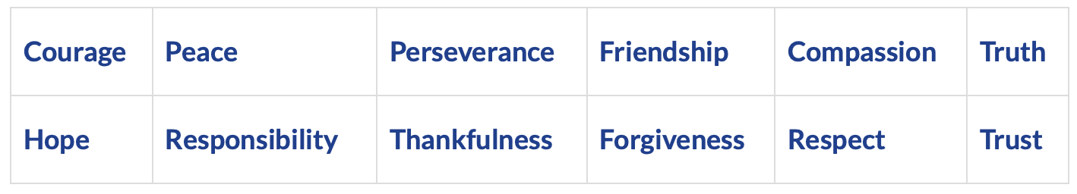

**Intent, Implementation and Impact**

|  |
| --- |
| **INTENT** |
| At Maryport Church of England Primary School, our intent is to empower pupils to become masters of technology. Recognising the role of technology in modern life, we aim to equip pupils with the skills, knowledge and understanding to use it positively, responsibly, and safely. Our broad and balanced computing curriculum encompasses the three core strands of the National Curriculum: Computer Science, Information Technology, and Digital Literacy. We ensure children develop as both creative users and confident creators of technology. We place a strong emphasis on e-safety, teaching key online safety themes throughout every year group in a progressive and age-appropriate manner. We also model positive digital behaviour as a whole-school community. We also understand the power of technology to enhance accessibility, creativity and engagement across the wider curriculum and encourage staff to embed computing meaningfully into other subject areas. Our knowledge-rich curriculum is carefully designed to offer pupils frequent opportunities to apply their learning in purposeful and creative ways. As a result, it promotes problem-solving, critical thinking and collaboration. By Upper Key Stage 2, pupils are expected to be digitally fluent and independent learners who are capable of selecting the most appropriate tools to express their ideas, solve problems and communicate effectively. This approach ensures our pupils are not only meeting national curriculum expectations but are well-prepared for the opportunities and challenges of an increasingly digital world. |

|  |
| --- |
| **IMPLEMENTATION** |
| At Maryport Church of England Primary School, computing is delivered through weekly timetabled lessons. All year groups have weekly allocated timings in the ICT suite, ensuring all pupils receive consistent and high-quality computing opportunities. Pupils also have access to 1:2 iPads across the school, with 1:1 iPads in Upper Key Stage 2, enabling them to apply their computing skills both within computing lessons and across other curriculum areas, supporting a blended and cross-curricular approach to learning. We follow a progressive computing curriculum using the Teach Computing scheme, which is carefully sequenced to build on prior learning and deepen pupils’ understanding across the three strands of the National Curriculum: Computer Science, Information Technology, and Digital Literacy. Lessons are designed to revisit key concepts, promote skill development over time and ensure children gain a strong foundation in computational thinking, creativity and responsible technology use. Staff integrate a wide range of digital tools and educational apps to enhance engagement and reinforce learning, both in computing and across the wider curriculum. This includes modelling skills, providing opportunities for independent exploration and encouraging collaborative digital projects. We encourage pupils to enjoy and value their computing education by focusing not only on how to use technology, but also on why it is used. We want learners to discuss, reflect and appreciate the impact computing has on their learning, development and well-being. |

|  |
| --- |
| **IMPACT** |
| At Maryport Church of England Primary School, pupils develop confidence and independence in using technology safely and creatively. They understand not only how to use computing tools but also why they are important, reflecting on the impact of computing on their learning and wellbeing. Pupils progressively build skills across computer science, information technology, and digital literacy, applying them both in computing lessons and across the curriculum. Access to devices like iPads enhances engagement and learning. Our emphasis on e-safety prepares pupils to be responsible digital people. As an Apple Distinguished School, we benefit from enhanced access to Apple’s cutting-edge technology, professional development and educational resources. This accreditation supports our commitment to high-quality computing education by enabling staff to deliver engaging, innovative lessons using a range of software and applications. Pupils gain confidence and fluency in using Apple technology, which fosters creativity, collaboration, and problem-solving skills. The accreditation also promotes a culture of continuous improvement and digital innovation within the school. Overall, at Maryport Church of England Primary School we prepare pupils for future learning and life in a technology-rich world. Our pupils leave well-equipped for secondary education and confident to thrive in their future computing journey. |

1. **Curriculum and Teaching:**

**National Curriculum (KS1 And KS2)**

**KS1 pupils should be taught to:**

* understand what algorithms are; how they are implemented as programs on digital devices; and that programs execute by following precise and unambiguous instructions
* create and debug simple programs
* use logical reasoning to predict the behaviour of simple programs
* use technology purposefully to create, organise, store, manipulate and retrieve digital content
* recognise common uses of information technology beyond school
* use technology safely and respectfully, keeping personal information private; identify where to go for help and support when they have concerns about content or contact on the internet or other online technologies.

**KS2 pupils should be taught to:**

* design, write and debug programs that accomplish specific goals, including controlling or simulating physical systems; solve problems by decomposing them into smaller parts
* use sequence, selection, and repetition in programs; work with variables and various forms of input and output
* use logical reasoning to explain how some simple algorithms work and to detect and correct errors in algorithms and programs
* understand computer networks including the internet; how they can provide multiple services, such as the world wide web; and the opportunities they offer for communication and collaboration
* use search technologies effectively, appreciate how results are selected and ranked, and be discerning in evaluating digital content
* select, use and combine a variety of software (including internet services) on a range of digital devices to design and create a range of programs, systems and content that accomplish given goals, including collecting, analysing, evaluating and presenting data and information
* use technology safely, respectfully and responsibly; recognise acceptable/unacceptable behaviour; identify a range of ways to report concerns about content and contact.

**Early Years**

In the Early Years Foundation Stage (EYFS) at Maryport Church of England Primary School computing is introduced through the areas of *Understanding the**World and Expressive Arts and Design*. The focus is on developing children’s early digital literacy and confidence with technology in a play-based and exploratory way. Children engage with age-appropriate devices such as tablets, interactive whiteboards and simple programmable toys like Bee-Bots. They develop basic skills in using a mouse, touchscreen and simple keyboard functions. There is also the opportunity to express their creativity through digital drawing and painting apps. Teaching computing encourages children to understand the purpose of technology in everyday life and promotes safe and respectful use. Additionally, EYFS computing activities often include simple problem-solving tasks. These can include sequencing stories or playing board games to build foundational computational thinking skills in a supportive environment.

**Progressive Skills**

Progressive computing skills are clearly mapped throughout the Teach Computing scheme, which we follow at Maryport Church of England Primary School. The scheme provides learning graphs and unit overviews that outline the specific skills and knowledge pupils will develop each term, ensuring a coherent and sequenced learning journey from Year 1 to Year 6 (refer to appendix 1). These documents demonstrate how children build on prior learning as they move through the strands of Computer Science, Information Technology, and Digital Literacy.

To support progression and assessment, we also use a school-wide skills map. This is used as a reference tool for teachers. This enables staff to identify key skills, track pupil progress and plan next steps in learning. It ensures that every child is supported and challenged appropriately in their computing education. The Teach Computing scheme also includes references to Key Stage 3 and Key Stage 4 content within the learning journey. This is particularly valuable for Year 6 teachers, as it provides insight into the computing knowledge and skills pupils will encounter in secondary school. By understanding what lies ahead, teachers can better prepare pupils for a smooth transition to Year 7. Staff can then reinforce foundational concepts and introduce key terminology and approaches that will support their continued progress in computing.

**Curriculum Structure**

At Maryport Church of England Primary School, the computing curriculum follows the Teach Computing scheme from Year 1 to Year 6. This structured programme ensures full coverage of the National Curriculum and provides a clear progression of skills across the three strands: Computer Science, Information Technology, and Digital Literacy. Each year group completes four units per year, with carefully sequenced lessons that revisit and build upon prior learning. The scheme includes high-quality lesson plans, resources, and assessment opportunities, supporting consistent and effective computing teaching across the school.

From September 2025, we will fully transition to delivering the Teach Computing scheme in its entirety. While our previous curriculum incorporated some elements of this scheme, we are now implementing it consistently across all year groups to ensure a coherent and progressive learning journey for all pupils (refer to appendix 2).

**Cross Curricular Opportunities**

Computing is embedded across the curriculum to enhance learning and creativity. In **English**, pupils use apps like Book Creator and Scratch for storytelling, persuasive writing and speech-to-text tools to support diverse learners. In **Maths**, coding games, iPads, spreadsheets and control technology like Bee-Bots help reinforce concepts and data skills. **Science** lessons include real-time data logging, digital presentations and safe online research. In **RE**, pupils create eBooks, animations and explore festivals through multimedia. **Geography** uses tools like Google Earth, digital fact files and weather data tracking. In **History**, pupils build timelines, research online and create digital documentaries. **Art and Design** incorporates digital painting, photo editing and animation. In **Music**, students compose using apps like GarageBand and explore rhythm through coding. **PSHE** aspects consider online safety aspects, children can create posters, animations and discuss online identity and behaviour.

1. **Online Safety:**

**Dedicated Half Termly Units**

At Maryport Church of England Primary School, we prioritise online safety by integrating the Project Evolve curriculum into our Computing policy. Project Evolve is a comprehensive, free-to-use resource, it provides a toolkit covering eight key strands:

* 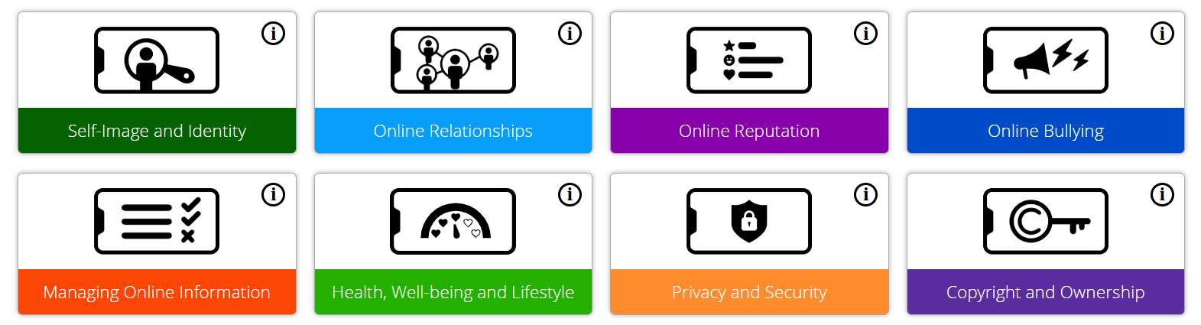Self-Image and Identity
* Online Relationships
* Online Reputation
* Online Bullying
* Managing Online Information
* Health, Wellbeing and Lifestyle
* Privacy and Security
* Copyright and Ownership

These strands are mapped across all age groups from Year 1 to Year 6 (EYFS can access the resources where appropriate), ensuring a progressive development of online safety knowledge and skills. At our school, we deliver explicit online safety lessons every half term, aligning with the Project Evolve framework. This approach is reinforced through our Computing curriculum, where students discuss how new computing skills impact their online safety. By integrating Project Evolve, we aim to equip our pupils with the knowledge and understanding to navigate the digital world safely and responsibly.

**Website:** [**https://projectevolve.co.uk**](https://projectevolve.co.uk)

**Reporting Concerns**

Safeguarding is central to our approach and all concerns related to computing or online safety are taken seriously. Staff are trained to identify and respond to potential e-safety issues. Including cyberbullying, inappropriate online behaviour or digital content. Any concerns are recorded and monitored using CPOMs (Child Protection Online Management System), our secure platform for managing safeguarding information. This allows designated safeguarding leads (DSLs) to track incidents effectively, intervene appropriately and ensure that all children are supported in a timely and confidential manner. By combining the educational strength of Project Evolve with robust safeguarding procedures, we aim to create a safe digital learning environment for every pupil.

**Reasonable Use and Parental Involvement**

At Maryport Church of England Primary School, we promote the responsible and reasonable use of technology and the internet as part of our commitment to providing a safe, respectful, and purposeful digital learning environment. Pupils are taught to use school devices (iPads and computers) safely and appropriately, in line with our educational expectations. To support this, we have a secure filtering and monitoring system in place that blocks access to unsuitable content and sends high-level alerts to staff if concerning searches or activity are detected. This allows us to respond swiftly to any potential risks. Pupils are regularly reminded of their responsibilities when using technology. We provide a comprehensive Online Safety Policy, accessible via our school website, and a Parental Use of Social Media Policy, which outlines appropriate and respectful use of social media in relation to the school community. Together, these measures help ensure a consistent and collaborative approach to digital safety across our school.

1. **Resources and Technology:**

**Hardware and Software**

The Teach Computing Curriculum, developed by the National Centre for Computing Education (NCCE), provides a comprehensive framework for teaching computing from Year 1 to Year 6. This curriculum encompasses a wide range of hardware and software tools designed to engage students in various aspects of computing, including programming, digital literacy and online safety. These hardware and software tools are integrated into the curriculum to provide a balanced and engaging computing education, ensuring that students develop the necessary skills to navigate and contribute to the digital world.

|  |  |
| --- | --- |
| **Hardware** | **Software** |
| * **Tablets and Laptops:** Devices such as iPads, and Windows computers are commonly used to access software applications and online resources. * **Bee-Bots:** These programmable floor robots are used in early years to introduce basic programming concepts through physical interaction. * **Micro:bit:** A pocket-sized computer that introduces students to physical computing and programming through hands-on projects. * **Crumbles:** A simple-to-use controller that allows students to create interactive projects, helping them understand the basics of physical computing. * **Digital Cameras and Microphones:** Used for creating and editing digital content, such as videos and podcasts, enhancing media literacy skills. | * **Scratch:** A visual programming language that enables students to create interactive stories, games, and animations, fostering creativity and problem-solving skills. * **Kodu:** A game development platform that allows students to design and build their own games, introducing them to game design and logic. * **Tynker:** An online platform offering coding courses that teach programming concepts through interactive lessons and projects. * **Microsoft Office Suite:** Applications like Word, Excel, and PowerPoint are used to develop digital literacy skills, including word processing, data handling, and presentations. * **Google Workspace:** Tools such as Google Docs and Slides facilitate collaborative work and cloud-based document creation and sharing. * **Audio and Video Editing Software:** Applications like Audacity and Windows Movie Maker are used for creating and editing audio and video content, supporting digital media skills. * **3D Modelling Software:** Programs like SketchUp are used in upper Key Stage 2 to introduce students to 3D design and modelling concepts. |

**Unplugged Resources**

At Maryport Church of England Primary School, we recognise the value of unplugged computing activities as an essential part of developing pupils' computational thinking from an early age. This allows pupils from EYFS through to Year 6 engage in hands-on, screen-free tasks. Aiming to support key concepts such as sequencing, algorithms, pattern recognition and logical reasoning. In EYFS, for example, children explore computing through activities like giving instructions, exploring hardware and programming simple floor robots such as Bee-Bots. Across Key Stage 1 and 2, unplugged tasks such as story sequencing, logic puzzles and debugging activities allow pupils to build foundational computing skills without the need for devices. These experiences not only enhance understanding of computing concepts but also contribute to broader curriculum aims by encouraging collaboration, problem-solving and critical thinking. Unplugged learning ensures that all pupils, regardless of their access to technology, can participate meaningfully in computing education.

1. **Staff Development:**

**Training Needs and Professional Development**

To effectively deliver the computing curriculum, primary school teachers need targeted training to build subject knowledge and confidence with digital tools. Online training for key platforms such as Scratch, Bee-Bots and Micro:bit can be accessed. Teachers also require guidance on unplugged activities, curriculum integration and adapting lessons for different year groups. At Maryport Church of England Primary School, staff meetings provide opportunities to discuss computing issues and updates. We also offer whole-school online safety training to ensure staff can promote safe internet use and respond to concerns. Access to Teach Computing modules, in-school coaching and collaborative planning supports staff in delivering a progressive and effective computing curriculum.

**The Role of the Subject Leader and Class Teachers**

The subject lead has to take responsibility for the development, evaluation and revision of schemes of work to ensure curriculum relevance and quality. They should support colleagues by advising on teaching resources, educational visits, guest speakers and innovative classroom practices. Monitoring of pupil work and analysis of student feedback needs to been carried out, alongside reviewing displays and conducting learning walks to maintain high standards. Resource audits should be completed to ensure each year group has appropriate materials. The lead should share relevant updates on educational developments, lead staff meetings and professional discussions, managed the IT suite timetable and promoted continued professional development through training opportunities and staff engagement.

The class teacher plays a vital role in delivering high-quality computing education by planning and teaching engaging lessons across Computer Science, Information Technology, and Digital Literacy. They adapt teaching to meet the diverse needs of all learners, including those with SEN and EAL. Also, formative and summative assessments are considered to guide progress and planning. Class teachers are responsible for promoting online safety, ensuring pupils understand how to use technology respectfully and responsibly. They integrate a variety of digital tools and resources to enhance learning and embed computing skills across the wider curriculum. Additionally, they stay informed about current developments in computing education through continuous professional development and collaborate with the computing lead and colleagues to support whole-school planning and the innovative use of technology.

1. **Monitoring and Review:**

**Monitoring and Assessment**

At Maryport Church of England Primary School, we monitor and assess computing through a combination of observation, discussion and digital evidence gathering. A key tool in our assessment strategy is Seesaw, which allows staff to upload photos, videos and examples of pupils’ work directly from computing lessons. This includes screenshots of programming tasks, videos of practical activities and photos of unplugged learning. Each class contributes to a dedicated whole-school Seesaw account specifically for computing, creating a centralised bank of evidence that showcases progression across all year groups. This approach not only supports internal assessment and curriculum monitoring but also enables us to share pupils’ achievements with parents, encouraging home-school engagement. The use of multimedia evidence allows teachers to capture a broader picture of pupil understanding beyond written work, supporting more accurate and meaningful assessment of computing skills.

**Review and evaluation**

Computing in our school can be reviewed and evaluated through a combination of monitoring, assessment, staff feedback and pupil voice. The following strategies occur across the year:

* Regular monitoring and discussions: in particular with staff members based upon the digital portfolios (Seesaw) to recognise the relevance, achievements and areas of development.
* Lesson observations and learning walks: to provide insight into the quality of teaching and pupil engagement across year groups.
* Reviewing planning against curriculum coverage: to ensure progression and consistency.
* Assessment data and evidence of pupil work: can be analysed to identify gaps in understanding or skills. We have a shared staff server which staff access each half term to upload data for their class. This includes the ability of each child stating if they are working at pre key stage, working towards, expected or greater depth.
* Gathering pupil voice: usually through questionnaires or group discussions to offer valuable insight into how learners perceive computing and where they may need further support.
* Staff feedback: this can be collected during staff meetings or CPD sessions to help identify areas for further training or resource development.
* Discussions between curriculum leader and senior leadership: to support ongoing improvement and ensures computing remains a well-embedded part of the school curriculum.

**Marking and Feedback**

Effective marking and feedback in computing are essential to support pupil progress, understanding and confidence in using technology. At Maryport Church of England Primary School we use a variety of feedback methods tailored to computing lessons to provide timely, meaningful, and constructive responses. By using a blend of these strategies, we aim to create a dynamic learning environment where pupils feel supported and motivated to develop their computing skills confidently. Below are some examples:

* Whole Class Verbal Feedback: Teachers provide immediate feedback during lessons, highlighting common successes and areas for improvement to the entire class.
* Modelling: Demonstrating key computing skills and processes (e.g. coding techniques and use of software) to support pupil learning and provide clear examples.
* Knowledge Checks: Regular informal checks such as quick quizzes or questioning to assess understanding and guide next steps.
* Quizzes on Blooket: Using interactive quiz platforms like Blooket to engage pupils and assess knowledge retention in a fun, gamified way.
* Self-Assessment: Pupils are encouraged to reflect on their own work to identify their strengths and areas for improvement using checklists.
* Live Whole Class Feedback: Providing real-time feedback during group activities or lessons, enabling immediate adjustments and collective learning.
* Live Individual Feedback: Offering one-to-one support and targeted advice during lessons or practical sessions to address individual pupil needs.

1. **Key Principles:**

**Inclusivity**

At Maryport Church of England Primary School, we are committed to teaching computing to all children, regardless of their ability or background. Computing forms a key part of our curriculum policy to provide a broad and balanced education that prepares every pupil for the digital world. Through our computing teaching, we provide learning opportunities that enable all pupils to make progress by setting suitable challenges and responding to each child’s individual needs.

* Computing activities are planned to challenge and engage all pupils appropriately, taking into account differences in **age, ability, ethnic background, gender,** and**language needs.**
* We recognise and support diverse learning styles, ensuring pupils have opportunities to work in ways that suit their individual preferences and strengths, including practical, visual and auditory approaches.
* Teaching resources and software are carefully selected to avoid stereotypes and bias related to **race, gender, disability**, or **social roles**, promoting equality and positive representation in technology and digital content.
* We address any issues of bias, exclusion or discrimination openly, clearly, and sensitively. This fosters a safe and inclusive learning environment where all pupils feel valued and supported in developing their computing skills.

**Challenge**

To challenge pupils in computing, it’s important to go beyond basic task completion and encourage them to think critically, experiment and take ownership of their learning. This can be achieved by offering open-ended tasks, such as designing their own game in Scratch, debugging more complex code or creating digital projects that combine multiple skills (e.g. combining research, design, and presentation). Pupils can be given opportunities to explain their thinking, evaluate their work and suggest improvements. Differentiated questioning, peer teaching and encouraging pupils to explore alternative solutions to a problem also help extend learning. Using real-world scenarios or linking computing to cross-curricular themes (e.g. using data handling in science) can provide meaningful contexts that deepen understanding. For higher-attaining pupils, introducing new tools such as Micro:bit or simple text-based programming (like Python where appropriate) can provide further challenge. Most importantly, fostering a growth mindset in computing—where experimentation, failure and revision are valued—helps pupils build resilience and develop more advanced computational thinking.

**Review and Evaluation**

The everyday use of communication technology is developing rapidly, with new technology being produced all the time. This policy therefore will be reviewed and revised regularly.

**Policy Date: June 2025**

**Review Date: June 2026**

Appendix 1.

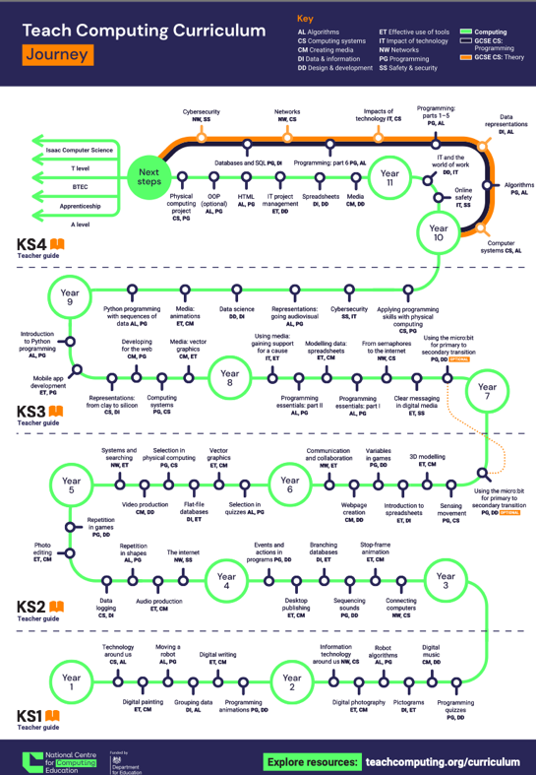

Appendix 2.

